C PROGRAMMING

MODULE 3

1. For Loop in C
Problem link: https://www.hackerrank.com/challenges/for-loop-in-c/problem
solution
#include <stdio.h>

int main(void)
{
int a, b;
const char *words[] = {
"one", "two", "three", "four", "five",
"six", "seven", "eight", "nine"
};

scanf("%d %d", &a, &b);

for (int i = a; i <= b; i++)
{
if (i >= 1 && i <= 9)
{
printf("%s\n", words[i - 1]);
}
else if (i > 9)
{
if (i % 2 == 0)
printf("even\n");
else
printf("odd\n");
}
}

return 0;
}


2. 1342 — Number of Steps to Reduce a Number to Zero
Problem link: https://leetcode.com/problems/number-of-steps-to-reduce-a-number-to-zero/
solution
int numberOfSteps(int num)
{
int steps = 0;

while (num > 0)
{
if (num % 2 == 0)
num = num / 2;
else
num = num - 1;

steps++;
}

return steps;
}
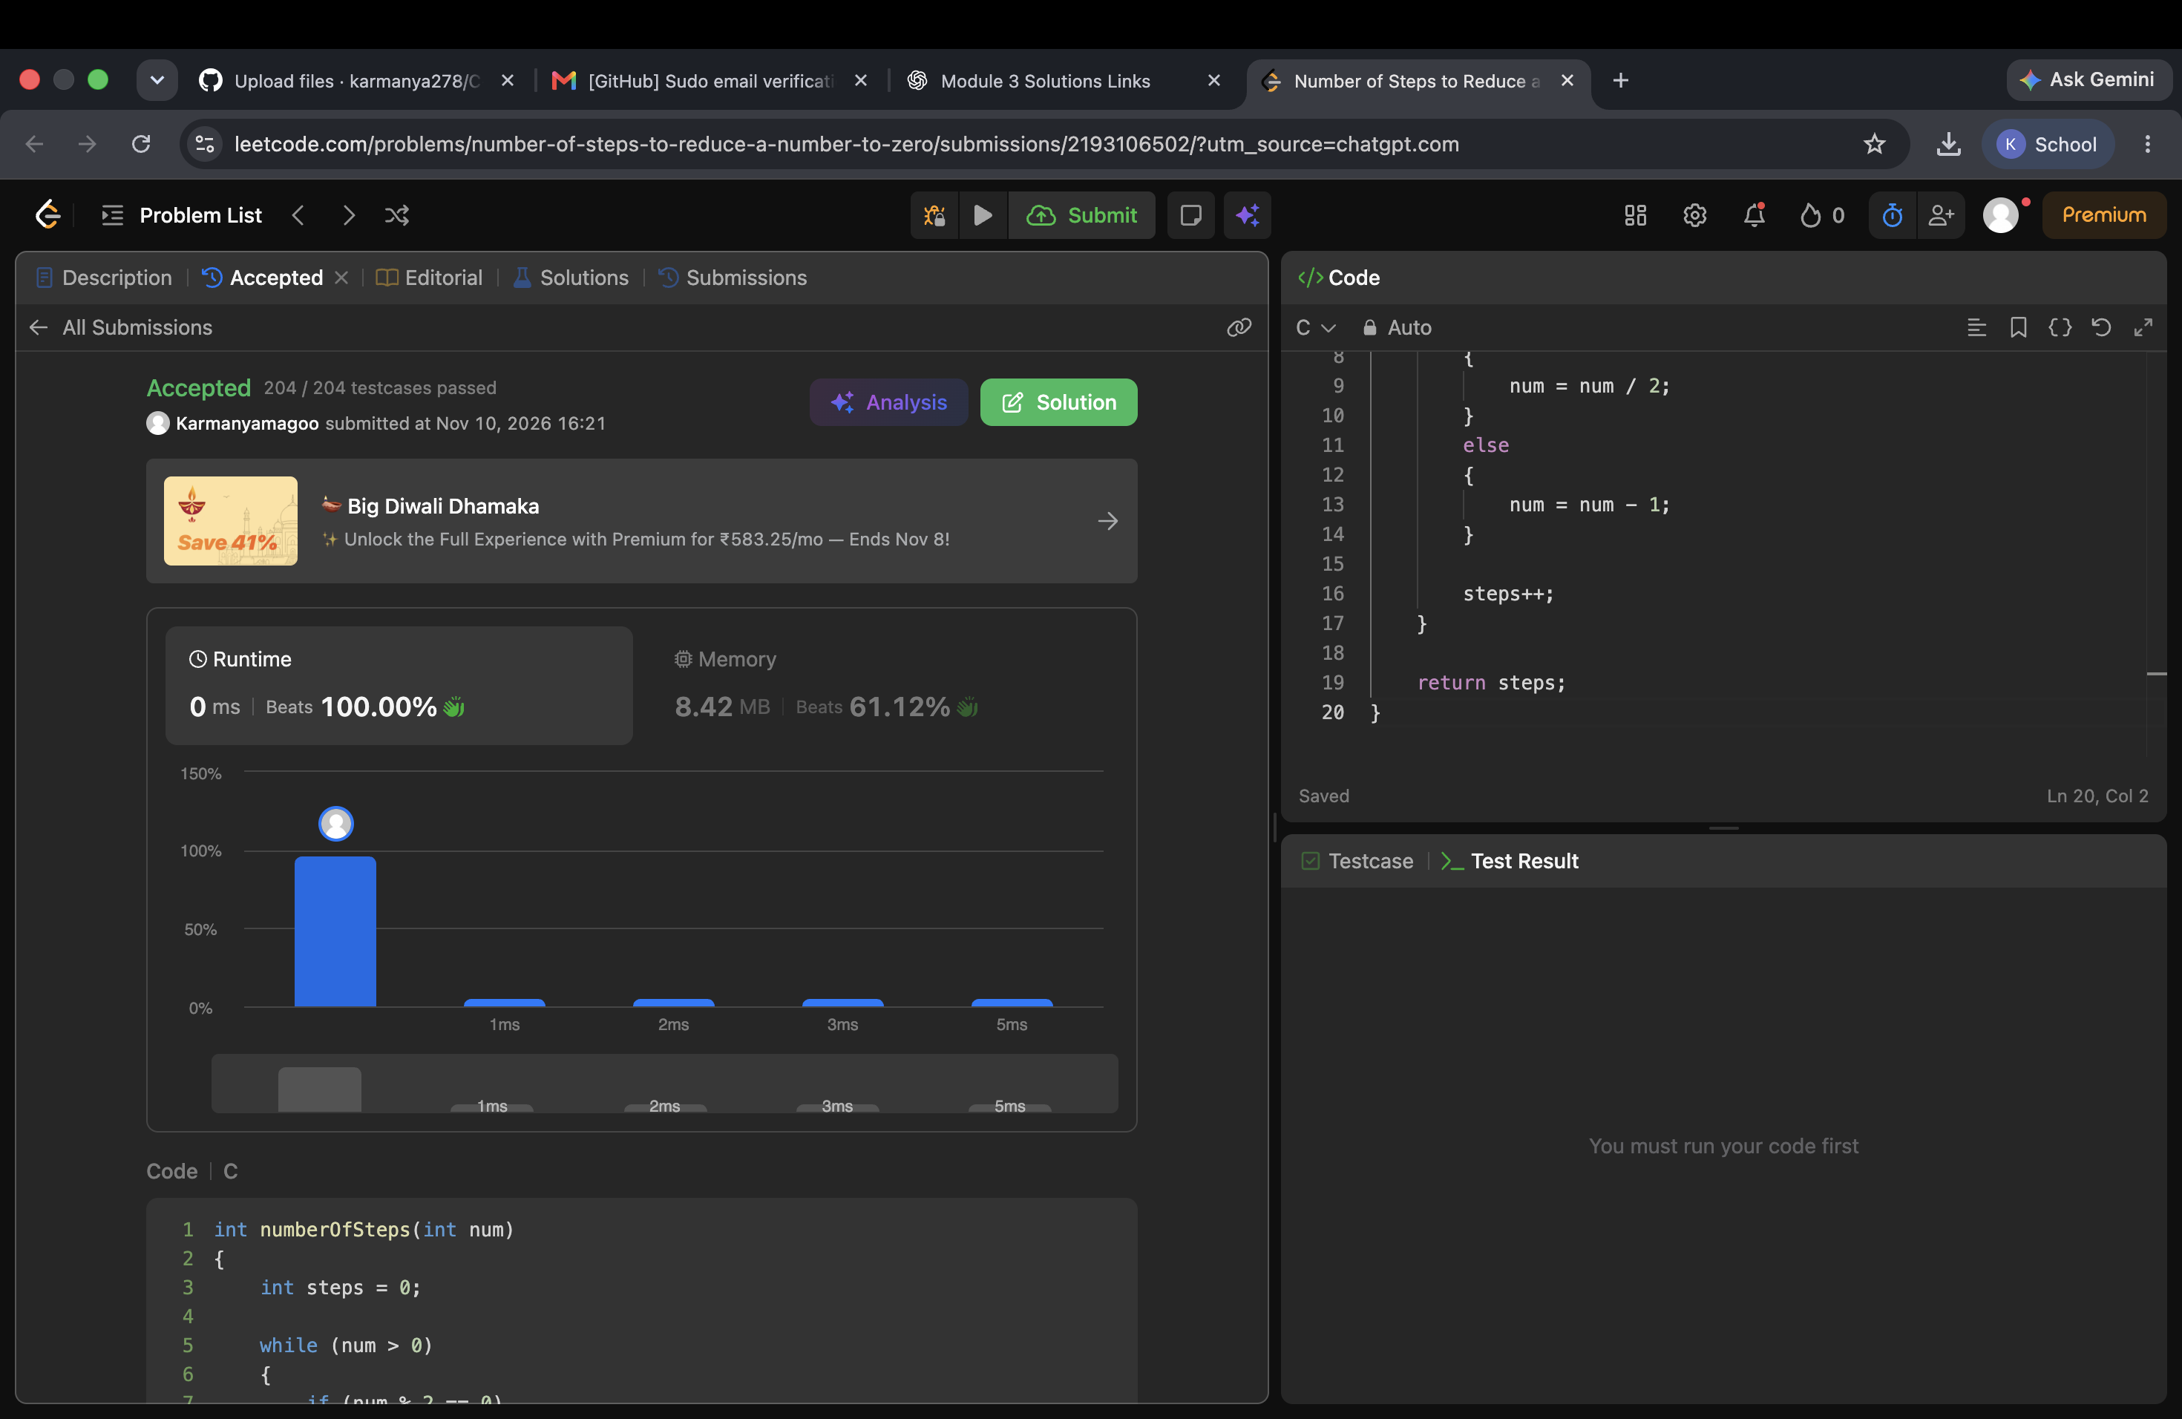

3. 2169 — Count Operations to Obtain Zero
Problem link: https://leetcode.com/problems/count-operations-to-obtain-zero/
solution
int countOperations(int num1, int num2)
{
int operations = 0;

while (num1 != 0 && num2 != 0)
{
if (num1 >= num2)
num1 = num1 - num2;
else
num2 = num2 - num1;

operations++;
}

return operations;
}
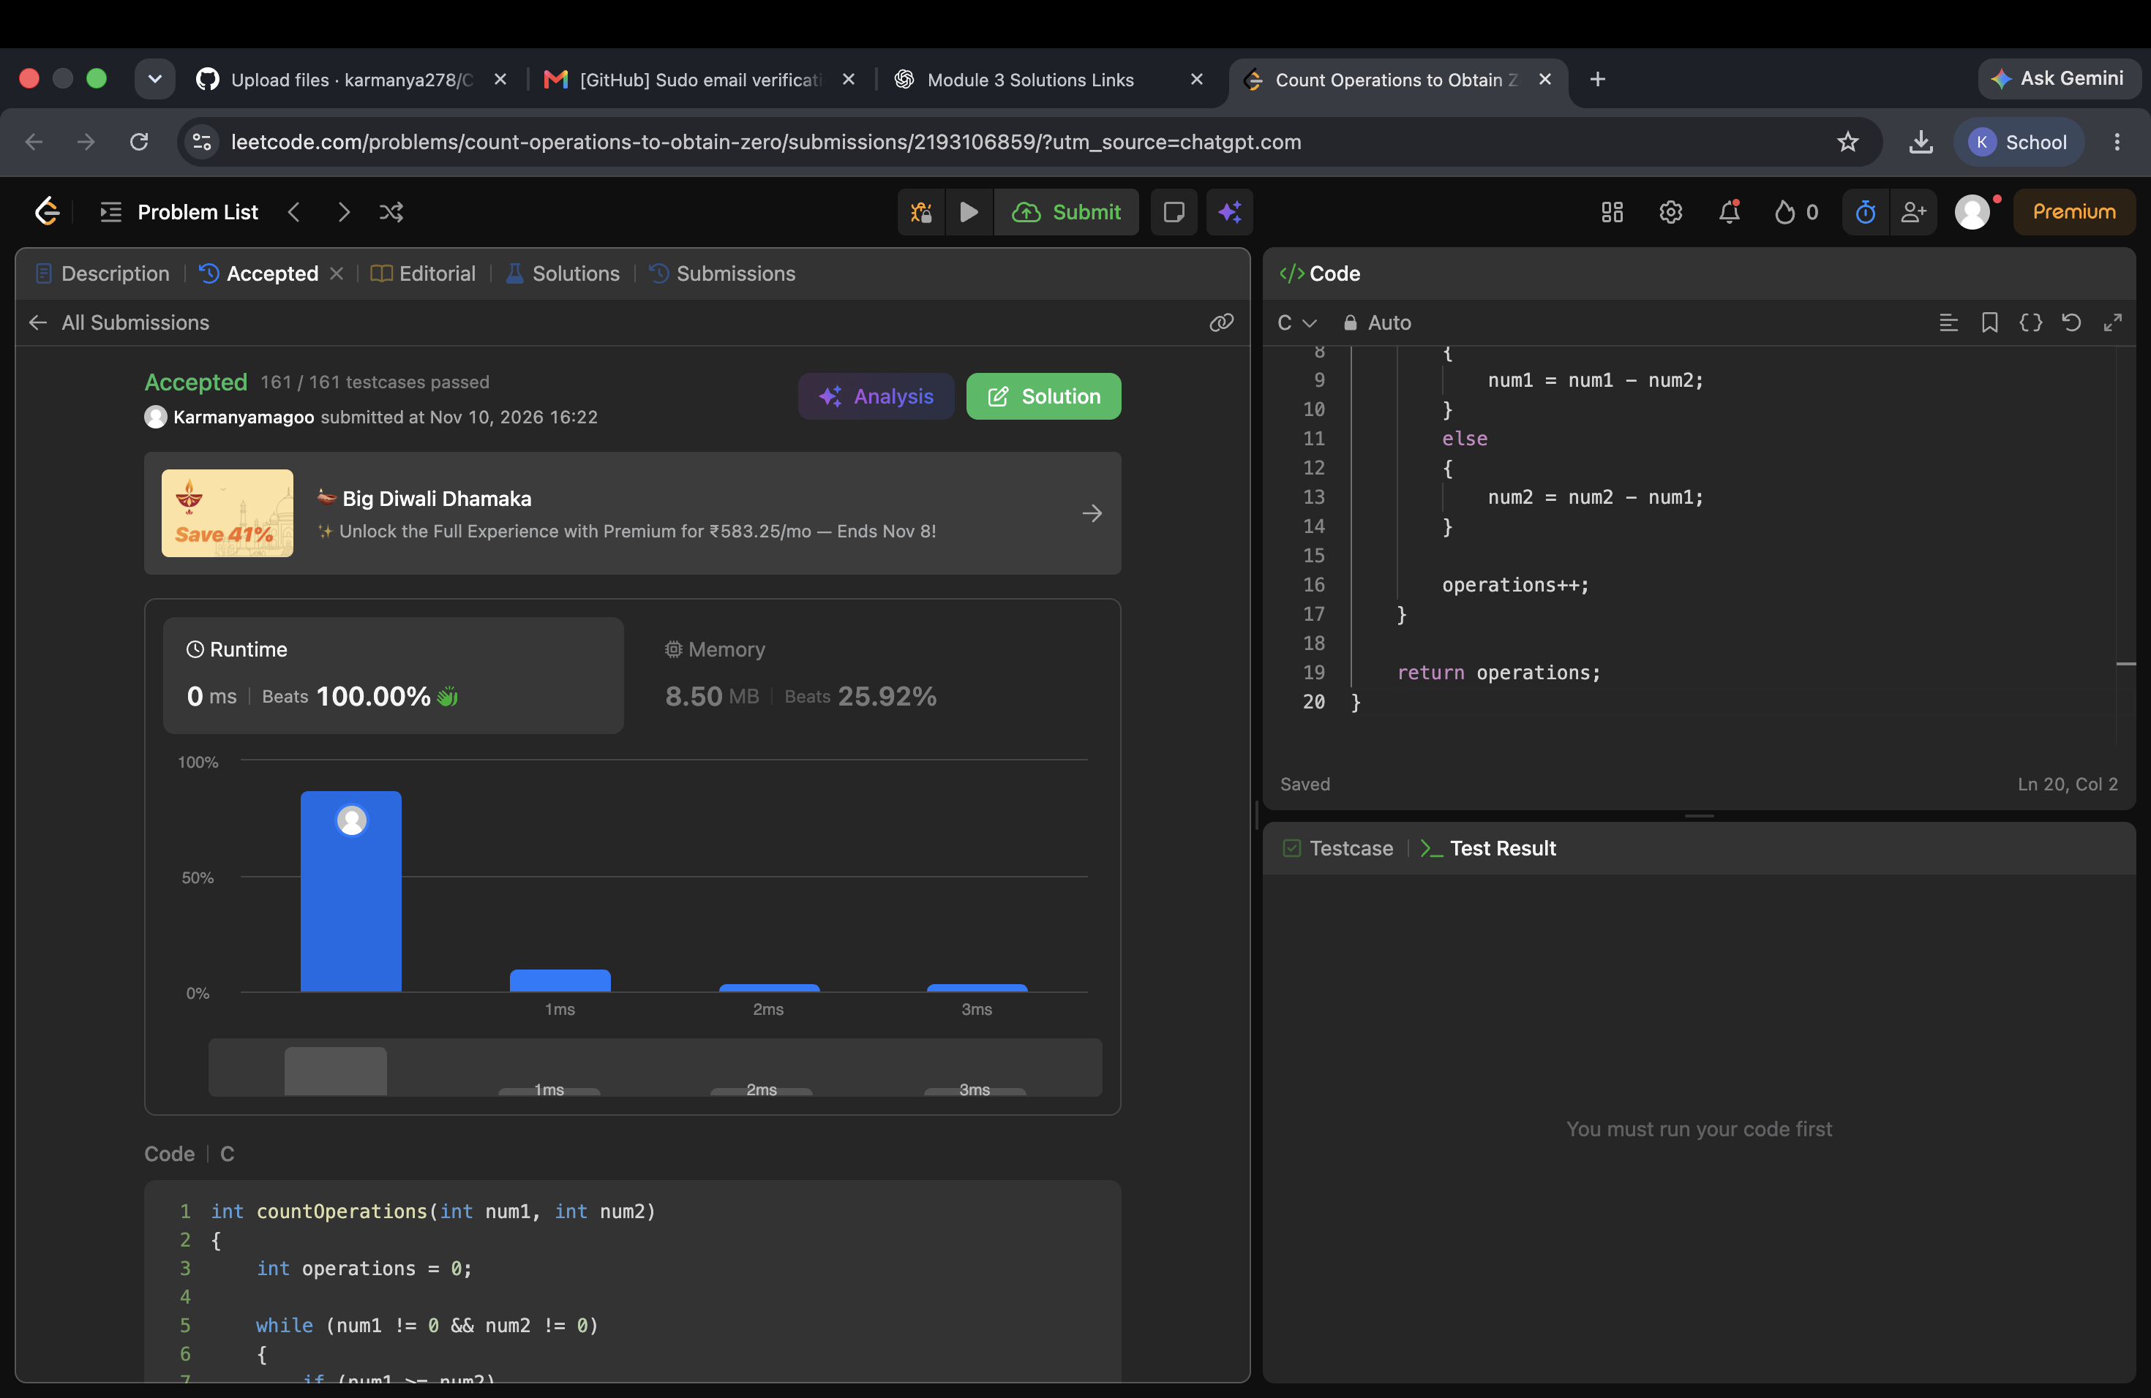

4. 1523 — Count Odd Numbers in an Interval Range
Problem link: https://leetcode.com/problems/count-odd-numbers-in-an-interval-range/
solution
int countOdds(int low, int high)
{
return (high + 1) / 2 - low / 2;
}
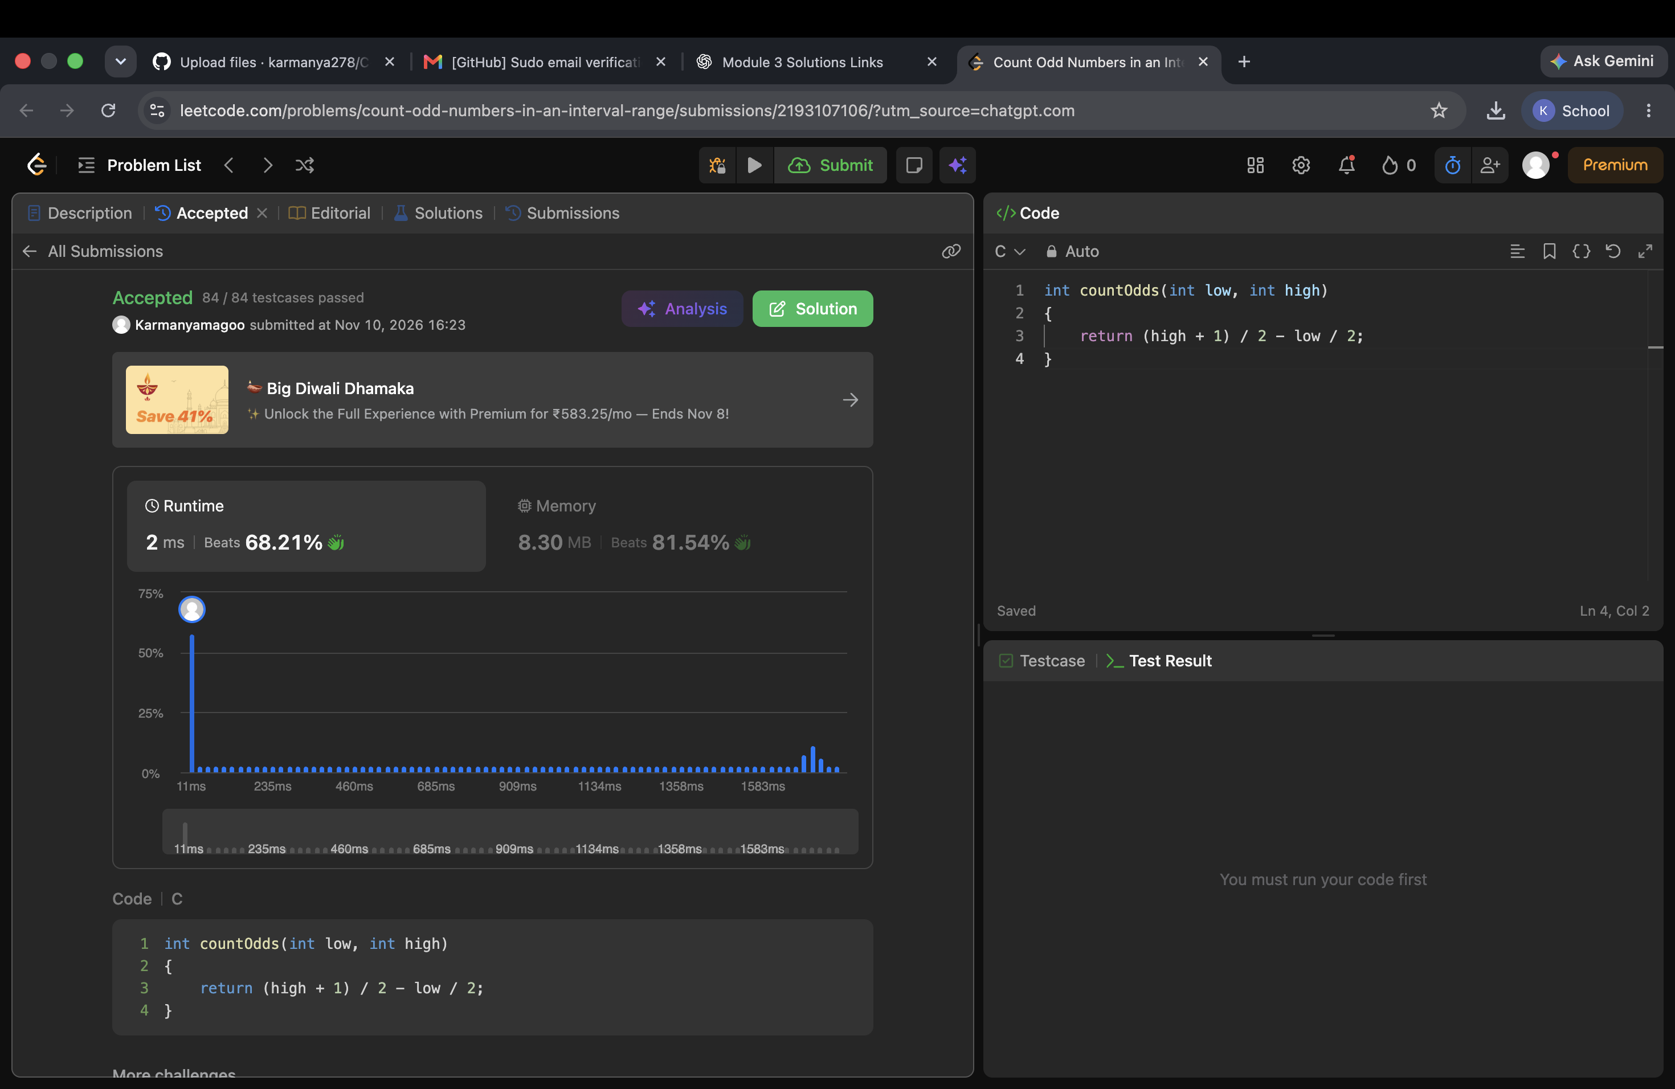

5. 2652 — Sum Multiples
Problem link: https://leetcode.com/problems/sum-multiples/
solution
int sumOfMultiples(int n)
{
int sum = 0;

for (int i = 1; i <= n; i++)
{
if (i % 3 == 0 || i % 5 == 0 || i % 7 == 0)
{
sum = sum + i;
}
}

return sum;
}
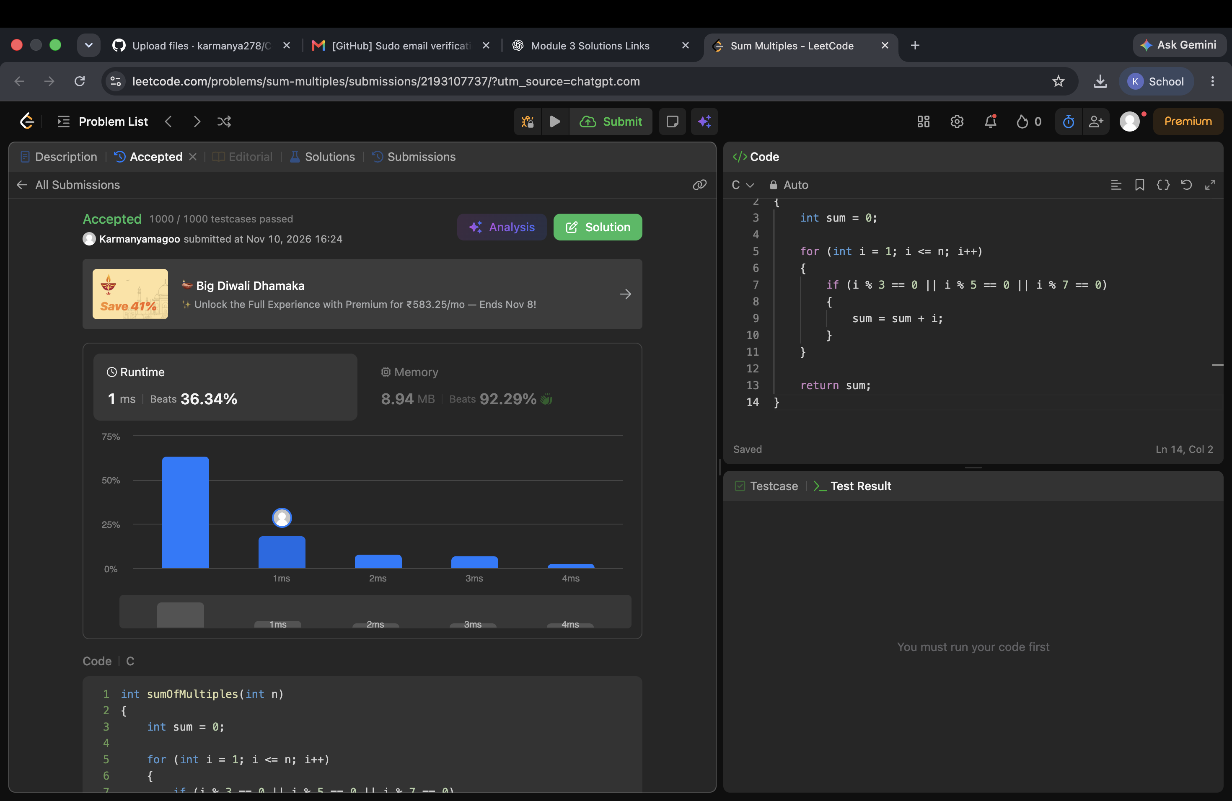

6. Number Line Jumps (Kangaroo)
Problem link: https://www.hackerrank.com/challenges/kangaroo/problem
solution
#include <stdio.h>

const char* kangaroo(int x1, int v1, int x2, int v2)
{
if (v1 == v2)
{
if (x1 == x2)
return "YES";
else
return "NO";
}

if ((x2 - x1) % (v1 - v2) == 0 &&
(x2 - x1) / (v1 - v2) >= 0)
{
return "YES";
}

return "NO";
}


